1. Sample input images
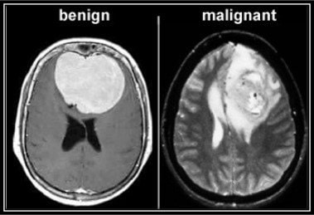
Benign and Malignant Tumour

2. Output of our Project
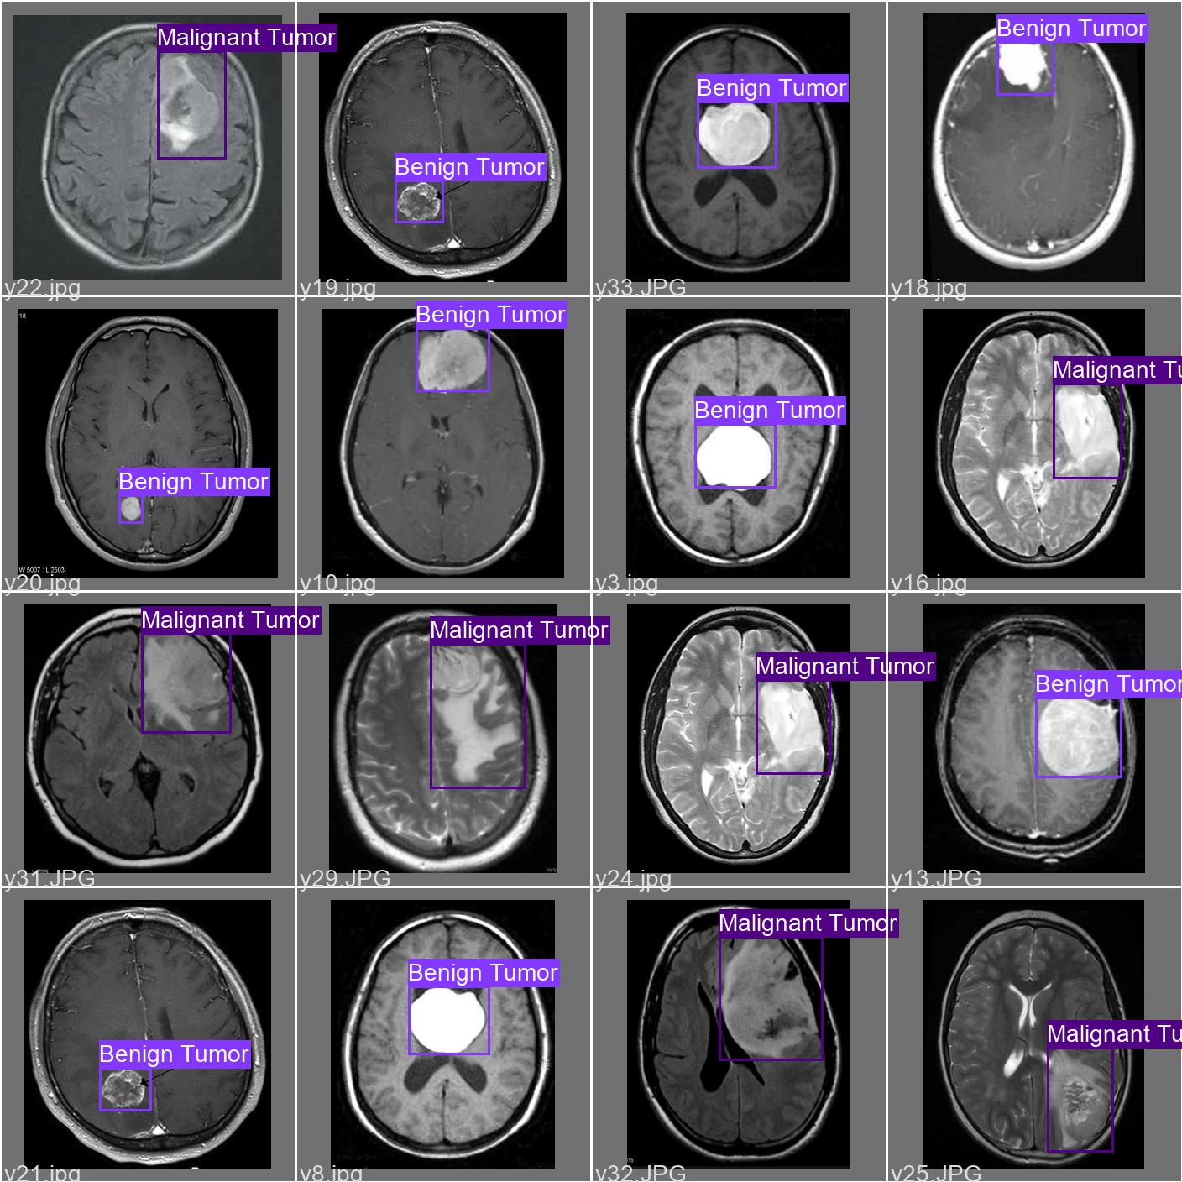

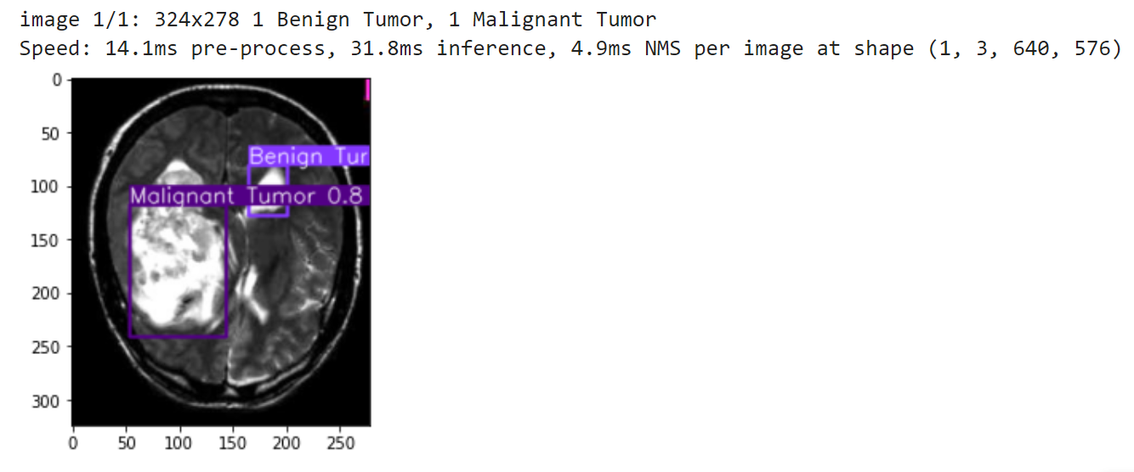

Now our software can detect both Malignant and Benign Tumours.

